|  |
| --- |
| AM36 |
| Modern Physics SH1012 |

|  |
| --- |
| Mattias Jönsson 940425-0673 and Yue Jiao 911024-7799  2015-04-20 |

Introduction

The nucleus of some isotopes are not stable and therefore emit radiation. Since this kind of radiation is dangerous if it interacts with the matter in our bodies, it is interesting for us to know how to stop it. To protect ourselves form radiation we can try to stop it by placing heavy matter between ourselves and the radiation source.

When gamma radiation travels through a material the energy of the radiation will not change, but the intensity of the radiation will decrease by $I=I_{0}e^{-μd}$, where $d$ is the travel-distance and $μ$ is a constant specific to the material and energy.

Theory

To be able to detect radiation one must make sure it interacts with matter in the detector. If not the radiation will pass through the detector and this will result in a failed detection. To make the radiation interact the detector uses what is called a scintillator, which is a device that contains a material which emits light when hit by ionizing radiation.

There are three different way to interact with the material that can happen when the gamma radiation enters the scintillator. The first is Compton scattering. In this case the gamma radiation will hit electrons within the scintillator and change directions and meanwhile give the collided electrons accelerations. The electrons will hit the surface of surrounding material and create photons because of photoelectric effect. And those photons are needed later for the intensity measurement.

The second interaction of gamma radiation and material is photo electric absorption. The gamma radiation will be absorbed by the surface of the scintillator and release electrons. In this way the gamma radiation will disappear and never pass the detector. And the created electrons are not going through the scintillator. So they will not affect the result.

But most of the radioactive materials shall have both gamma radiation and beta radiation. And electrons from beta radiation will disorder our experiment. Thus we need a scintillator with a thick bottom to block the electrons from passing the scintillator.

The last way of gamma radiation interact with material is the so called pair production. There the gamma radiation will then translate to a pair of electrons. To make this happens we need the incoming photons to have energy at least greater than two times mass energy of electrons which is around 1.022MeV.(<http://physics.nist.gov/cgi-bin/cuu/Value?mec2mev>) However the radiation source we are using does not have such high energy level so we do not need to consider this process.

The photons released because of Compton scattering will then enter the PMT (photo multiplier tube). Within the PMT there are several metal plates. When the photons come in and hit the metal plates it will release electrons. And the PMT has a great potential between ends. So the electrons will be accelerated and then hit off more electrons when it meet other metal plates. This process will magnify the intensity of electrons by about ${10}^{6}$ times according to the experiment assistant. Thus it will create a current for measuring.

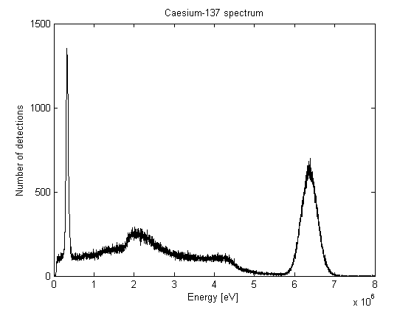Depending on the type of radiation the scintillator is built differently. For beta radiation it is sufficient with a thinner scintillator to make sure the beta electrons transfer all there energy to the material inside. And if we want to measure beta radiation we need a radiation material that is not closed, i.e. it should not be sealed by plastic. The plastic can stop beta radiation so it might help while measuring the gamma radiation. The window which leads into the scintillator must be thin enough so it doesn’t prevent the beta radiation from entering. For gamma radiation the scintillator is thicker so the gamma photons are given a chance to transfer their energy to the material inside. The window must be thicker to prevent beta radiation from entering the scintillator and to make sure the gamma photons doesn’t pass through the device.

Figure 1. The spectrum from Cesium-137

(Skulle vi inte lägga den här delen i resultat eller diskussion?)

The gamma spectrum from the decay of a specific isotope is discrete, but the detected spectrum doesn’t only consist of discrete peaks. The explanation is that different types of interactions occur and these interactions give different characteristics. Given the spectrum from the decay of Cesium-137 (see figure 1) it is possible to identify these interactions.

The first peak comes from the so called characteristic X-rays that are created when fast electrons hit a dense material. It is hard to differentiate if these X-rays come from the sample itself or if they come from interactions with some other metal.

The continuous area comes from Compton scattering, when a gamma photon doesn’t release all its energy in the scintillator. Unlike photo electric absorption, when all energy is transferred to an electron, in Compton scattering the photon might give an electron some energy and then scatter in another direction. If the photon then leaves the scintillator without further interactions the detector will only detect the energy which the photon released in the collision. Since the amount of energy released in the collision is dependent on the angle and since the angle is continuous the energy will also be continuous. The highest amount of energy that could be released in Compton scattering is when the photon backscatters and this explains why this continuous area ends with a sharp edge. The peak in the continuous area comes from Compton scattering that occurs in the lead box and then enters the detector.

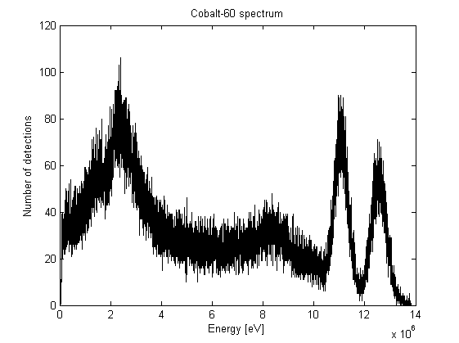The last peak comes from the gamma radiation that are stopped in the scintillator. Since all energy is released in the detector (it is possible that these photons first Compton scatter and then is absorbed) and since these photons have a discrete energy this part of the spectrum is discrete. In this case the peak is at $611.7 keV$, which is the energy of the gamma photons released when Cesium-137 decay.

Figure 2. The spectrum of Cobalt-60

Given the spectrum from the decay of Cobalt-60 (see figure 2) it is also possible to identify the different characteristics. Unlike Cesium-137, however, in this spectrum there are two different edges where the Compton scattering ends. The first is clearly visible at $9 keV$ and the other occurs at $10 keV$. The first peak is likely X-rays and the two last peaks come from the gamma rays.

Experimental Setup

**Equipment**

|  |  |
| --- | --- |
| Box of lead | Sample of Am-241 enclosed in plastic |
| Detector (for gamma) | Sample of Co-60 enclosed in plastic |
| Dial caliper | Sample of Cs-137 enclosed in plastic |
| Lead plates | Tin plates |

We first start the measure software Tukan and clear the existing data. And then we change the “Stopping condition” in Tukan to make it measures for 1 minute and the time option to “Measurement time”.

Now we take a Cs-137 and put it inside the lead cub under the detector. Then we press the start button to start measuring. When the measurement is finished we save the data in a file. Now we put the two ROI lines at both sides of rightest hill of the graph as it has been showed here. Here we will find the mean value that is showed in the statistic window. Then we go to the calibration window and write the mean value we just get in the polynomial window and write the main photon peak of Cs-137 in the corresponding box. The channel corresponding to each gamma ray peak was measured and compared to the same energy given in NuDat. Here we perform the so called calibration. And then we go back to the measuring window.

Now we put a plastic plate that has a hole in the middle above the plate that holds the Cs-137 we just used in the lead box. After that we put varies amount of lead plates on the holy plastic plate. Meanwhile we measure the thickness of those lead plates from each edge. And we do the same thing to get the mean value by using the same ROI lines. We repeat the process until we use all the lead plates, i.e. 19 plates.

Then we do the exact same thing instead that we use tin plates instead of lead. Here we get a lot of statistics too.

After the Cs-137 experiment we perform the same experiment with Co-60. And here we will get three numbers in the calibration windows. Then we let the software calculate a second degree polynomial to fit those three numbers. The detectors channels were then calibrated to the corresponding energy levels by the second degree polynomial.

After the Co-60 experiment we move on to use the Am-241. Here we do not need to fill anything in the calibration window because it is already calibrated. And we do not need 19 lead plates either. The statistics we get by using 1 lead plates or up to 3 tin plates will be enough.

After we have collected all the statistic we put all material back and the experiment part is then finished.

Results

|  |  |
| --- | --- |
| Lead Width [mm] | Ce-137 611,7 kEV Intensity [detections/s] |
| 0 | 2633,9 |
| 1,96 | 2160,2 |
| 3,84 | 1769,7 |
| 5,98 | 1445,7 |
| 9,98 | 1142,4 |
| 19,835 | 411,9 |
| 29,785 | 140,6 |

|  |  |  |
| --- | --- | --- |
| Lead Width [mm] | Co-60 1173,2 kEV Intensity [detections/s] | Co-60 1332,5 kEV Intensity [detections/s] |
| 0 | 470,8 | 371,6 |
| 1,96 | 421,8 | 332,4 |
| 3,84 | 381,5 | 303,3 |
| 9,98 | 275,7 | 222,1 |
| 19,835 | 163,9 | 127,5 |
| 37,775 | 60,5 | 47,4 |

|  |  |
| --- | --- |
| Lead Width [mm] | Am-241 59,5 kEV Intensity [detections/s] |
| 0 | 3370,8 |
| 0,3 | 977,4 |
| 0,86 | 118 |
| 1,5 | 46,1 |

|  |  |
| --- | --- |
| Tin Width [mm] | Ce-137 611,7 kEV Intensity [detections/s] |
| 0 | 2633,9 |
| 2 | 2385,3 |
| 4 | 2162,4 |
| 6 | 1996,8 |
| 10 | 1934,7 |
| 20 | 1210 |
| 30 | 775 |

|  |  |  |
| --- | --- | --- |
| Tin Width [mm] | Co-60 1173,2 kEV Intensity [detections/s] | Co-60 1332,5 kEV Intensity [detections/s] |
| 0 | 470,8 | 371,6 |
| 2 | 440,9 | 347 |
| 4 | 414,5 | 327,7 |
| 10 | 358,7 | 277,5 |
| 20 | 257,8 | 194,9 |
| 30 | 186,7 | 142,6 |

Discussion

(Vet inte om det ska vara här och exakt hur vi ska lägga ihop dem.)

We need to use the “Measurement time” option to increase the accuracy of measurement. It is because that after the detector get a hit of gamma radiation it will shut itself down for a short while. Thus if we use the “Real time” option we will not get the gamma radiation that comes counted while the detector is off. That will increase the inaccuracy. However with the “Measurement time” option counts only the time while the detector is on. And that is what we need.

We do not need to measure the intensity of gamma radiation from the Am-241 when we are using more than one lead plate or more than three tin plates because the Am-241 has a quite low radiation energy. So those plates will completely block all the gamma radiation. However the detector will still show a small amount of detection. They come from different sources and are pretty much unexplainable. We do not need to consider them neither. The number of tin plates needed to stop all gamma radiation from Am-241 is decided experimental. We stopped while the result of detection become too disordered.